**CRON JOB**

Cron jobs are commonly used to automate repetitive tasks such as system maintenance, backups, updates, and administrative functions without manual intervention.

Cron is most suitable for scheduling repetitive tasks.

**CRON JOB SYNTAX:**

**MINUTE HOUR DOM MONTH DOW**

1. MINUTES - Minutes in one hour (0-59)
2. HOURS - Hours in one day (0-23)
3. DAY MONTH - Day in a month (1-31)
4. MONTH - Month in a year (1-12)
5. DAYWEEK - Day of the week (0-7) where 0 and 7 are Sunday

**Step1: Create a New item using freestyle project:**

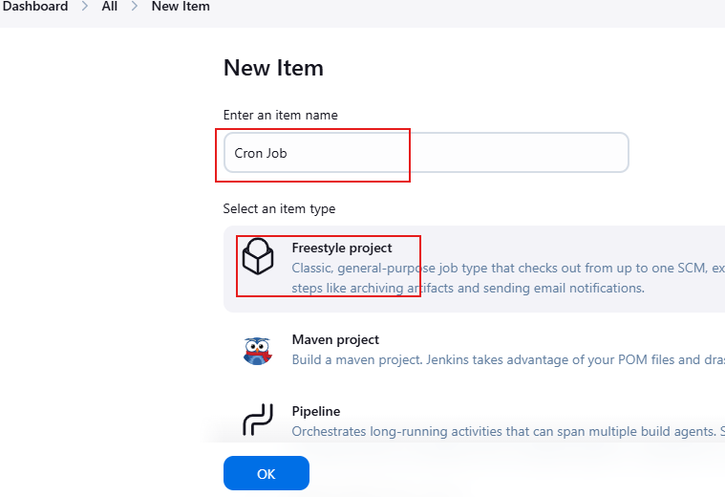

**Step 2: Click "Configure" of the job requirement, and scroll down to "Build Triggers". Click on the check Box of Build periodically. Add time schedule in the Schedule field.**

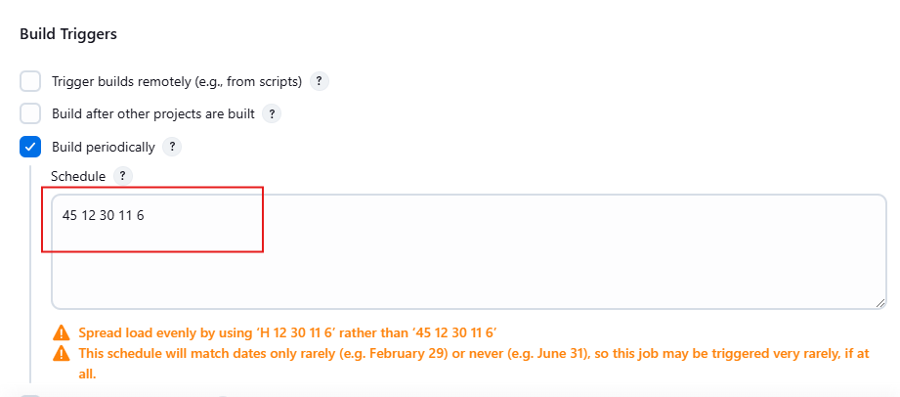

Build got success at the exact time scheduled for build:

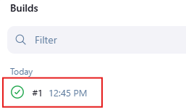

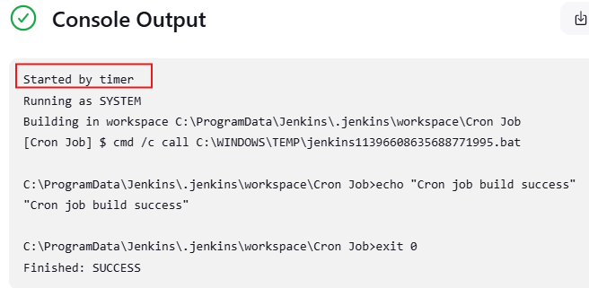

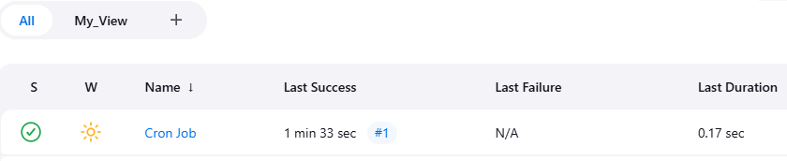

**CRON JOB FOR SCHEDULE TASK:**

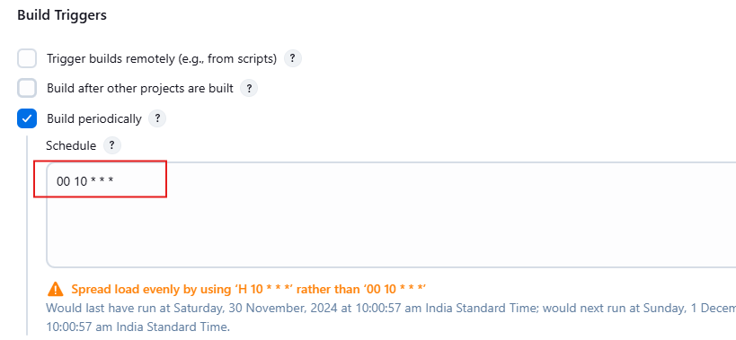

**Another example: How to run only on a specific day of the week:**

# Every Sunday at 19:00

1. 19 * * 0

**How many days a week you can add a comma like this:**

# Monday, Wednesday, and Friday:

0 19 * * 1,3,5